**[연습문제]**

1. AdapterView 클래스의 하위의 클래스를 10개를 나열하라.

2. 리스트뷰의 모양을 표현하는 클래스 상수에는 android.R.layout.simple_list_item_1 외에 무엇이 있는지 조사해 보자.

3. [예제 11-8]에서 BaseAdapter 클래스를 상속받을 때, 완성되는 getCount(), getItem() 등의 추상메소드는 어느 인터페이스에 속하는가?

4. ( 1 )는 사진이나 이미지를 배치하고 좌우로 스크롤 해서 볼 수 있도록 제공하며, ( 2 )는 PC의 드롭 다운(Drop Down) 박스와 비슷한 기능을 한다.

5. 10장의 <실습 10-2> 명화 선호도 투표의 첫 화면을 그리드뷰로 변경해서 프로젝트를 작성하라.

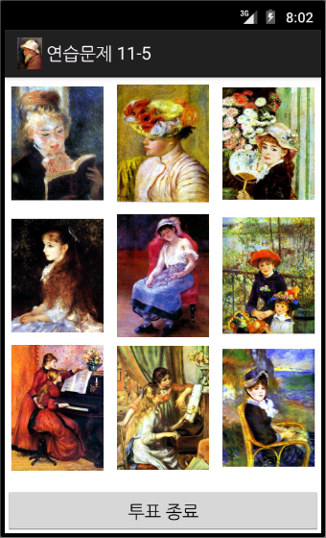

6. <직접 풀어보기 11-3>을 개선해서, 영화 포스트가 이미지 뷰가 아닌 9장의 [예제 9-6]의 MyGraphicView에 출력되도록 프로젝트를 작성 하라. 또, 컨텍스트 메뉴로 [그림 9-2]의 기하학적 변환이 되도록 하라.

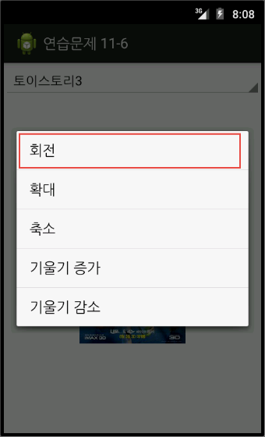 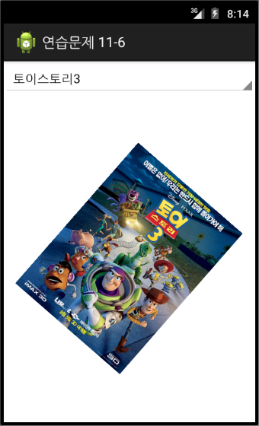

**[연습문제-답안]**

1. AbsListView, AbsSpinner, AdapterViewAnimator, AdapterViewFlipper, ExpandableListView, Gallery, GridView, ListView, Spinner, StackView

2.

simple_dropdown_item_1line

simple_expandable_list_item_1

simple_expandable_list_item_2

simple_gallery_item

simple_list_item_1

simple_list_item_2

simple_list_item_activated_1

simple_list_item_activated_2

simple_list_item_checked

simple_list_item_multiple_choice

simple_list_item_single_choice

simple_selectable_list_item

simple_spinner_dropdown_item

simple_spinner_item

3. android.widget.Adapter

4. (1) 갤러리 (2) 스피너

5.

*** activity_main.xml ***

<LinearLayout xmlns:android="http://schemas.android.com/apk/res/android"

android:layout_width="fill_parent"

android:layout_height="fill_parent"

android:orientation="vertical" >

<GridView

android:id="@+id/gridView1"

android:layout_width="match_parent"

android:layout_height="0dp"

android:layout_weight="9"

android:gravity="center"

android:numColumns="3" >

</GridView>

<Button

android:id="@+id/btnResult"

android:layout_width="match_parent"

android:layout_height="0dp"

android:layout_weight="1"

android:text="투표 종료" />

</LinearLayout>

*** result.xml *** 🡺 변경 없음

<TableLayout xmlns:android="http://schemas.android.com/apk/res/android"

android:layout_width="match_parent"

android:layout_height="match_parent"

android:gravity="center_vertical"

android:stretchColumns="0" >

<TableRow>

<TextView

android:id="@+id/tv1"

android:layout_gravity="center_vertical"

android:text="그림1"

android:textSize="15dp" />

<RatingBar

android:id="@+id/rbar1"

style="?android:attr/ratingBarStyleIndicator"

android:layout_width="match_parent"

android:layout_height="wrap_content"

android:layout_gravity="right" >

</RatingBar>

</TableRow>

<TableRow>

<TextView

android:id="@+id/tv2"

android:layout_gravity="center_vertical"

android:text="그림2"

android:textSize="15dp" />

<RatingBar

android:id="@+id/rbar2"

style="?android:attr/ratingBarStyleIndicator"

android:layout_width="match_parent"

android:layout_height="wrap_content"

android:layout_gravity="right" >

</RatingBar>

</TableRow>

<TableRow>

<TextView

android:id="@+id/tv3"

android:layout_gravity="center_vertical"

android:text="그림3"

android:textSize="15dp" />

<RatingBar

android:id="@+id/rbar3"

style="?android:attr/ratingBarStyleIndicator"

android:layout_width="match_parent"

android:layout_height="wrap_content"

android:layout_gravity="right" >

</RatingBar>

</TableRow>

<TableRow>

<TextView

android:id="@+id/tv4"

android:layout_gravity="center_vertical"

android:text="그림4"

android:textSize="15dp" />

<RatingBar

android:id="@+id/rbar4"

style="?android:attr/ratingBarStyleIndicator"

android:layout_width="match_parent"

android:layout_height="wrap_content"

android:layout_gravity="right" >

</RatingBar>

</TableRow>

<TableRow>

<TextView

android:id="@+id/tv5"

android:layout_gravity="center_vertical"

android:text="그림5"

android:textSize="15dp" />

<RatingBar

android:id="@+id/rbar5"

style="?android:attr/ratingBarStyleIndicator"

android:layout_width="match_parent"

android:layout_height="wrap_content"

android:layout_gravity="right" >

</RatingBar>

</TableRow>

<TableRow>

<TextView

android:id="@+id/tv6"

android:layout_gravity="center_vertical"

android:text="그림6"

android:textSize="15dp" />

<RatingBar

android:id="@+id/rbar6"

style="?android:attr/ratingBarStyleIndicator"

android:layout_width="match_parent"

android:layout_height="wrap_content"

android:layout_gravity="right" >

</RatingBar>

</TableRow>

<TableRow>

<TextView

android:id="@+id/tv7"

android:layout_gravity="center_vertical"

android:text="그림7"

android:textSize="15dp" />

<RatingBar

android:id="@+id/rbar7"

style="?android:attr/ratingBarStyleIndicator"

android:layout_width="match_parent"

android:layout_height="wrap_content"

android:layout_gravity="right" >

</RatingBar>

</TableRow>

<TableRow>

<TextView

android:id="@+id/tv8"

android:layout_gravity="center_vertical"

android:text="그림8"

android:textSize="15dp" />

<RatingBar

android:id="@+id/rbar8"

style="?android:attr/ratingBarStyleIndicator"

android:layout_width="match_parent"

android:layout_height="wrap_content"

android:layout_gravity="right" >

</RatingBar>

</TableRow>

<TableRow>

<TextView

android:id="@+id/tv9"

android:layout_gravity="center_vertical"

android:text="그림9"

android:textSize="15dp" />

<RatingBar

android:id="@+id/rbar9"

style="?android:attr/ratingBarStyleIndicator"

android:layout_width="match_parent"

android:layout_height="wrap_content"

android:layout_gravity="right" >

</RatingBar>

</TableRow>

<TableRow>

<Button

android:id="@+id/btnReturn"

android:layout_width="wrap_content"

android:layout_height="wrap_content"

android:layout_span="2"

android:text="돌아가기" />

</TableRow>

</TableLayout>

*** 메인 Java ***

package com.cookandroid.exercise11_5;

import android.app.Activity;

import android.content.Context;

import android.content.Intent;

import android.os.Bundle;

import android.view.View;

import android.view.ViewGroup;

import android.widget.BaseAdapter;

import android.widget.Button;

import android.widget.GridView;

import android.widget.ImageView;

import android.widget.Toast;

public class MainActivity extends Activity {

final int voteCount[] = new int[9];

final String imgName[] = { "독서하는 소녀", "꽃장식 모자 소녀", "부채를 든 소녀",

"이레느깡 단 베르양", "잠자는 소녀", "테라스의 두 자매", "피아노 레슨", "피아노 앞의 소녀들", "해변에서" };

@Override

protected void onCreate(Bundle savedInstanceState) {

super.onCreate(savedInstanceState);

setContentView(R.layout.activity_main);

setTitle("연습문제 11-5");

final GridView gv = (GridView) findViewById(R.id.gridView1);

MyGridAdapter gAdapter = new MyGridAdapter(this);

gv.setAdapter(gAdapter);

Button btnFinish = (Button) findViewById(R.id.btnResult);

btnFinish.setOnClickListener(new View.OnClickListener() {

public void onClick(View v) {

Intent intent = new Intent(getApplicationContext(),

ResultActivity.class);

intent.putExtra("VoteCount", voteCount);

intent.putExtra("ImageName", imgName);

startActivity(intent);

}

});

}

public class MyGridAdapter extends BaseAdapter {

Context context;

public MyGridAdapter(Context c) {

context = c;

}

public int getCount() {

return posterID.length;

}

public Object getItem(int position) {

// TODO Auto-generated method stub

return null;

}

public long getItemId(int position) {

// TODO Auto-generated method stub

return 0;

}

Integer[] posterID = { R.drawable.pic1, R.drawable.pic2,

R.drawable.pic3, R.drawable.pic4, R.drawable.pic5,

R.drawable.pic6, R.drawable.pic7, R.drawable.pic8,

R.drawable.pic9 };

public View getView(int position, View convertView, ViewGroup parent) {

ImageView imageview = new ImageView(context);

imageview.setLayoutParams(new GridView.LayoutParams(150, 200));

imageview.setScaleType(ImageView.ScaleType.FIT_CENTER);

imageview.setPadding(5, 5, 5, 5);

imageview.setImageResource(posterID[position]);

for (int i = 0; i < 9; i++)

voteCount[i] = 0;

final int pos = position;

imageview.setOnClickListener(new View.OnClickListener() {

public void onClick(View v) {

voteCount[pos]++;

Toast.makeText(getApplicationContext(),

imgName[pos] + ": 총 " + voteCount[pos] + " 표",

Toast.LENGTH_SHORT).show();

}

});

return imageview;

}

}

}

*** ResultActivity.java *** 🡺 변경 없음

package com.cookandroid.exercise11_5;

import android.app.Activity;

import android.content.Intent;

import android.os.Bundle;

import android.view.View;

import android.widget.Button;

import android.widget.RatingBar;

import android.widget.TextView;

public class ResultActivity extends Activity {

@Override

protected void onCreate(Bundle savedInstanceState) {

// TODO Auto-generated method stub

super.onCreate(savedInstanceState);

setContentView(R.layout.result);

setTitle("투표 결과");

// 앞 화면에서 보낸 투표 결과 값을 받는다.

Intent intent = getIntent();

int[] voteResult = intent.getIntArrayExtra("VoteCount");

String[] imageName = intent.getStringArrayExtra("ImageName");

// 9개의 TextView, RatingBar 객체배열

TextView tv[] = new TextView[imageName.length];

RatingBar rbar[] = new RatingBar[imageName.length];

// 9개의 TextView, RatingBar ID 배열

Integer tvID[] = { R.id.tv1, R.id.tv2, R.id.tv3, R.id.tv4, R.id.tv5,

R.id.tv6, R.id.tv7, R.id.tv8, R.id.tv9 };

Integer rbarID[] = { R.id.rbar1, R.id.rbar2, R.id.rbar3, R.id.rbar4,

R.id.rbar5, R.id.rbar6, R.id.rbar7, R.id.rbar8, R.id.rbar9 };

// TextView, RatingBar 개체 찾기.

for (int i = 0; i < voteResult.length; i++) {

tv[i] = (TextView) findViewById(tvID[i]);

rbar[i] = (RatingBar) findViewById(rbarID[i]);

}

// 각 TextVeiw 및 RatingBar에 넘겨 받은 값을 반영.

for (int i = 0; i < voteResult.length; i++) {

tv[i].setText(imageName[i]);

rbar[i].setRating((float) voteResult[i]);

}

Button btnReturn = (Button) findViewById(R.id.btnReturn);

btnReturn.setOnClickListener(new View.OnClickListener() {

public void onClick(View v) {

finish();

}

});

}

}

6.

*** activity_main.xml ***

<LinearLayout xmlns:android="http://schemas.android.com/apk/res/android"

android:layout_width="fill_parent"

android:layout_height="fill_parent"

android:orientation="vertical" >

<LinearLayout

android:id="@+id/iconLayout"

android:layout_width="fill_parent"

android:layout_height="0dip"

android:layout_weight="1"

android:gravity="center"

android:orientation="horizontal" >

<Spinner

android:id="@+id/spinner1"

android:layout_width="match_parent"

android:layout_height="wrap_content" />

</LinearLayout>

<LinearLayout

android:id="@+id/pictureLayout"

android:layout_width="fill_parent"

android:layout_height="0dip"

android:layout_weight="9"

android:gravity="center"

android:orientation="horizontal" >

</LinearLayout>

</LinearLayout>

*** Java 코드 ***

package com.cookandroid.exercise11_6;

import android.app.Activity;

import android.content.Context;

import android.graphics.Bitmap;

import android.graphics.BitmapFactory;

import android.graphics.Canvas;

import android.os.Bundle;

import android.view.ContextMenu;

import android.view.ContextMenu.ContextMenuInfo;

import android.view.MenuItem;

import android.view.View;

import android.widget.AdapterView;

import android.widget.ArrayAdapter;

import android.widget.LinearLayout;

import android.widget.Spinner;

public class MainActivity extends Activity {

MyGraphicView graphicView;

static Integer selectedPoster;

static float scaleX = 1, scaleY = 1;

static float angle = 0;

static float skewX = 0, skewY = 0;

@Override

public void onCreate(Bundle savedInstanceState) {

super.onCreate(savedInstanceState);

setContentView(R.layout.activity_main);

setTitle("연습문제 11-6");

LinearLayout pictureLayout = (LinearLayout) findViewById(R.id.pictureLayout);

graphicView = (MyGraphicView) new MyGraphicView(this);

pictureLayout.addView(graphicView);

registerForContextMenu(graphicView);

final String[] movie = { "쿵푸팬더", "짱구는 못말려", "아저씨", "아바타", "대부", "국가대표",

"토이스토리3", "마당을 나온 암탉", "죽은 시인의 사회", "서유기" };

final Integer[] posterID = { R.drawable.mov21, R.drawable.mov22,

R.drawable.mov23, R.drawable.mov24, R.drawable.mov25,

R.drawable.mov26, R.drawable.mov27, R.drawable.mov28,

R.drawable.mov29, R.drawable.mov30 };

Spinner spinner = (Spinner) findViewById(R.id.spinner1);

ArrayAdapter<String> adapter;

adapter = new ArrayAdapter<String>(this,

android.R.layout.simple_spinner_item, movie);

spinner.setAdapter(adapter);

spinner.setOnItemSelectedListener(new AdapterView.OnItemSelectedListener() {

public void onItemSelected(AdapterView<?> arg0, View arg1,

int arg2, long arg3) {

selectedPoster = posterID[arg2];

graphicView.invalidate();

}

public void onNothingSelected(AdapterView<?> arg0) {

// TODO Auto-generated method stub

}

});

}

@Override

public boolean onContextItemSelected(MenuItem item) {

// TODO Auto-generated method stub

switch (item.getItemId()) {

case 1:

angle = angle + 20;

graphicView.invalidate();

return true;

case 2:

scaleX = scaleX + 0.2f;

scaleY = scaleY + 0.2f;

graphicView.invalidate();

return true;

case 3:

scaleX = scaleX - 0.2f;

scaleY = scaleY - 0.2f;

graphicView.invalidate();

return true;

case 4:

skewX = skewX + 0.1f;

skewY = skewY + 0.1f;

graphicView.invalidate();

return true;

case 5:

skewX = skewX - 0.1f;

skewY = skewY - 0.1f;

graphicView.invalidate();

return true;

}

return super.onContextItemSelected(item);

}

@Override

public void onCreateContextMenu(ContextMenu menu, View v,

ContextMenuInfo menuInfo) {

// TODO Auto-generated method stub

if (v == graphicView) {

menu.add(0, 1, 0, "회전");

menu.add(0, 2, 0, "확대");

menu.add(0, 3, 0, "축소");

menu.add(0, 4, 0, "기울기 증가");

menu.add(0, 5, 0, "기울기 감소");

}

}

private static class MyGraphicView extends View {

public MyGraphicView(Context context) {

super(context);

}

@Override

protected void onDraw(Canvas canvas) {

super.onDraw(canvas);

int cenX = this.getWidth() / 2;

int cenY = this.getHeight() / 2;

canvas.skew(skewX, skewY);

canvas.scale(scaleX, scaleY, cenX, cenY);

canvas.rotate(angle, cenX, cenY);

Bitmap picture = BitmapFactory.decodeResource(getResources(),

selectedPoster);

int picX = (this.getWidth() - picture.getWidth()) / 2;

int picY = (this.getHeight() - picture.getHeight()) / 2;

canvas.drawBitmap(picture, picX, picY, null);

picture.recycle();

}

}

}